**Project Summary**

**Overview:**

This project will investigate how habitat fragmentation impacts seed dispersal mutualisms and the resulting consequences for plant populations. It is predicted that plant species that depend on a narrow range of dispersal agents are most vulnerable to environmental changes which might jeopardize their mutualist dispersers. The proposed research examines the response of understory forest plant populations to change in seed dispersal services along a gradient of forest fragmentation. Biological collections of plants in the UConn herbaria provide critical historical data in order to compare the responses of ant-dispersed and vertebrate-dispersed plant populations to environmental change. This collections data, along with integrated field experiments will determine if specialized seed dispersal determines the susceptibility of plants to population decline, altered local plant spatial population structure, and shifted co-evolutionary interactions between seed-dispersing mutualists and plants. The PI will gain substantial training in ecological modeling, statistics, spatial ecology, and GIS. Data collected will directly address the impact of habitat fragmentation on forest plants, including several rare species. Research activities provide opportunities for undergraduate students from underrepresented groups and outreach programs will engage the public in local forest conservation.

**Intellectual Merit:**

The consequences of lost species interactions due to habitat fragmentation are currently poorly understood. Research on habitat fragmentation often identifies the impacts of habitat disturbance on single species across a range of fragmentation regimes, while the proposed project examines a broader array of species in shared habitat, determining population changes in 40 species of understory plants from two plant guilds. This project will also take a comparative approach to determine if relative impact of habitat fragmentation is determined by seed dispersal specialization, with ant-dispersal representing a higher degree of specialization compared to vertebrate-dispersal. Furthermore, this project will use biological collections in order to consider long-term changes that have occurred, improving the understanding of habitat fragmentation since the majority of studies examine short-term changes in plant populations. The proposed project will therefore address gaps in population ecology and conservation, by examining the impact of forest fragmentation on an entire community of understory plants in a shared habitat type.

**Broader Impacts:**

The broader impacts of the proposed work include contributions to monitoring of rare plants, training opportunities for the PI and students from underrepresented groups, and components of public outreach. First, the proposed project will follow up on populations of conservation interest, contributing to active monitoring efforts as proposed collections work by the PI will update site records of rare forest plants. These records will improve UConn’s herbaria collections, which act as a reference for future conservation efforts. Second, the experiments will improve PI training in quantitative techniques, including GIS and modern statistical techniques for dealing with spatially and phylogenetically correlated data (Generalized Least Squares and Bayesian Hierarchical Models). Second, the Sponsor currently supports McNair scholars, and the proposed project will enable these students to participate in experiments studying the seed dispersal mutualisms. Third, during the course of the proposed project the PI will be involved in outreach for the Connecticut Forest and Park Association and the Connecticut Department of Energy and Environmental Protection and collaborating with other projects.

**Project Description**

**Introduction**

Habitat fragmentation dramatically restructures species interactions, however the mechanisms that determine a population’s susceptibility to fragmentation are still unclear in most cases (Fahrig 2003, Ewers and Diham 2005, Fischer and Lindenmayer 2007, doublecheck refs). Recent work has demonstrated that species involved in specialized or obligate interactions are more vulnerable to environmental change caused by fragmentation (Laurance et al. 2011, Liu et al. 2016, Rocha-Santos et al. 2016). Seed dispersal mutualisms are abundant in terrestrial communities and can involve a diversity of animal taxa as dispersal agents, which vary in degree of specialization (Bronstein et al. 2006). Plant species that depend on a single animal dispersal agent are more negatively impacted by reduced seed dispersal services than those that rely on many dispersal agents (Aguilar et al. 2006). Loss of specialized seed dispersal services reduces plant population size (Laurance et al. 2006 add ref), changes local spatial structure within plant populations (Harrison et al. 2013 add ref from temperate ecosystem), and can lead to novel co-evolutionary dynamics between plants and newly recruited seed dispersing mutualists (Kiers et al. 2010, add ref from herbs). Despite many studies demonstrating the multiple consequences of fragmentation on attributes of plant populations, there is a paucity of integrative studies linking the effects of fragmentation to changes in seed dispersal services. Herbarium collections can therefore provide a critical link between historical and contemporary plant populations in order to understand the impacts of habitat fragmentation.

Many herbaceous plants and shrubs specialize in seed dispersal by ants (Rico-Gray and Oliveira 2007, Lengyel et al. 2010). These “myrmecochores” rely on ants to rapidly disperse seeds to microsites adjacent to ant nests, which function as safe locations away from seed predators (Garrido et al. 2009, Gomez and Espadaler 2013). This evolutionarily convergent dispersal syndrome is characterized by a suite of plant traits (Lengyel et al. 2010): Myrmeochocore seeds have appendages called “elaiosomes” that are nutrient-rich organs consumed by ants during seed dispersal. Also, ant-dispersed plants typically produce larger seeds than closely-related vertebrate-dispersed plants of similar size (Thompson 1981, Guitian and Garrido 2006), and individual plants produce proportionally fewer seeds per generation (Gomez and Espadaler 2013). These seed traits seem to be the product of selection by ants because workers prefer seeds with the largest elaiosomes and therefore the largest seeds (Peters et al. 2003, Bas et al. 2009) and there is no benefit to producing more seeds than can be dispersed by ants, as any surplus seeds are prone to high rates of predation (Fedriani 2004). As a consequence, myrmecochocores specialize on only few ant species in a given habitat while also producing a small number of seeds that are highly vulnerable to predation (Ness and Morin 2008, Warren and Giladi 2014). The traits therefore greatly increase the susceptibility of these plants to environmental change and loss of ant mutualists compared to less specialized seed-dispersal syndromes (Ness et al. 2004, Lach et al. 2010).

The proposed project will concentrate on mymechochory to link degradation of a dispersal mutualism in forest fragments to population declines, spatial reorganization, and evolutionary change in the plant partners. Using data from herbarium specimens, experiments will take a comparative approach to this problem by contrasting the responses of ant-dispersed and vertebrate-dispersed plant populations to historical habitat fragmentation. Although habitat fragmentation is likely to affect plants reliant on both dispersal modes negatively, this project will investigate three potential ways in which ant-dispersed plants may be impacted more than vertebrate-dispersed plants. First, without the appropriate ant mutualist, plant populations will experience high rates of mortality from seed predators (Ness and Morin 2008, Kwit et al. 2012) and consequently face population declines (Ness and Morin 2008). Second, reduced seed dispersal increases the proximity of seedlings to parent plants (Canner et al. 2012), leading to more clustered distribution of plant populations (Harrison et al. 2013, add ref from temperate forests). Third, changes to ant communities may change natural selection regimes for certain seed traits, particularly seed size (Bas et al. 2009).

**Hypothesis and predictions**

This study will compare the population and evolutionary consequences of forest fragmentation for ant-dispersed and vertebrate-dispersed plant species and in particular will address the following three hypotheses

1. ***Population persistence hypothesis (PPH)*** *The persistence of ant-dispersed plant populations will be reduced in small forest fragments more than vertebrate-dispersed species.*  
   In small fragments, mutualistic services provided by ants are reduced (Ness and Morin, 2008), in turn reducing seed dispersal to safe sites, survival, and ultimately population persistence of ant-dispersed plants.
2. ***Spatial structure hypothesis (SSH)*** *Loss of mutualistic services by ants will lead to increased spatial clustering of ant-dispersed plant populations compared to vertebrate-dispersed populations.*

Ant species found in disturbed habitats are ineffective dispersers (Gomez et al. 2003). Reduced seed dispersal will cause recruitment proximate to parent plants. As a result, reduced seed dispersal by ants in smaller fragments will increase the spatial clustering of myrmecochores.

1. ***Dispersal co-evolution hypothesis (DCH)*** *Ant-dispersed plant populations in small fragments will experience selection for smaller seed size. Ant species found in small fragments are not able to move relatively large seeds, and the relationship between seed size and fragment size will be more negative for ant-dispersed species than vertebrate-dispersed plant species.*Comparative work has shown that, in native plant ranges, average myrmecochore seed size declines where average ant body size is smaller (Garrido et al. 2002). Ants found in fragmented habitats have a smaller average body size and there is a negative relationship between dispersal success and ant body size (Ness et al. 2004). As a result, we predict that seed sizes of myrmecochorous species will have declined over time since fragmentation occurred.

Fig 1. Predicted hypothetical response for vertebrate and ant-dispersed plant populations

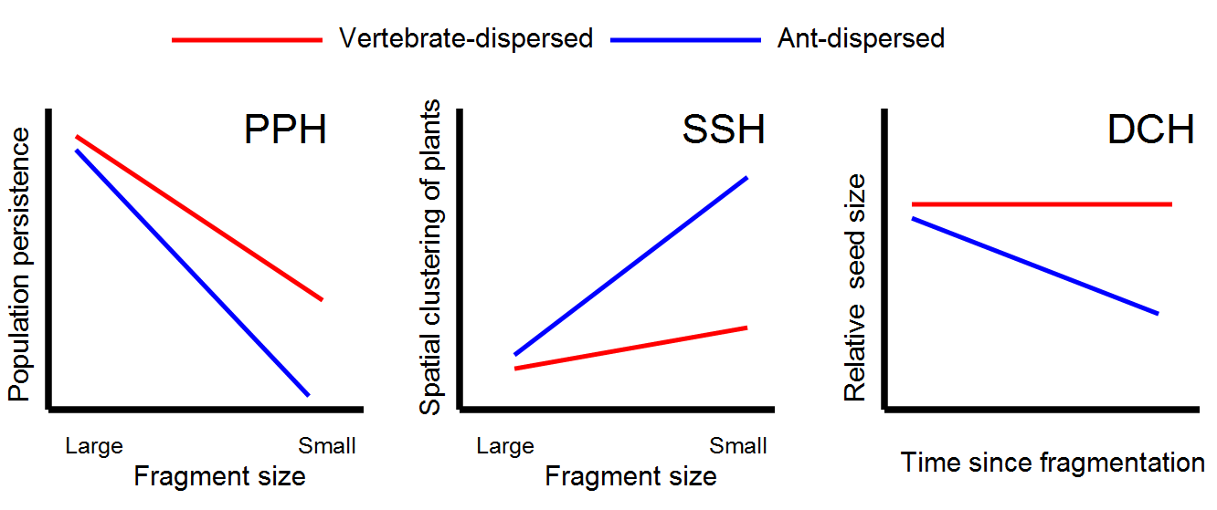

**Methods**

**Study system**

At the turn of the 20th century, forests in the Northeastern U.S. experienced a dramatic resurgence when human land use changed from cropland and pasture to woodlots (Foster 1992, Radeloff et al. 2005). Connecticut currently has 60% forest cover, but development has split these habitats into increasingly smaller fragments over the last 30 years, as reported by the Center for Land Use and Education Research (CLEAR, 2012). The proposed research will use detailed records of forest coverage by CLEAR and records forest plants in UConn’s Herbarium. Herbaria provide physical specimens and locality information for a large number of ant-dispersed and vertebrate-dispersed plants (Fig. 2).

The proposed project examines understory plant communities of Northeastern U.S. forests. At least twenty species of ant-dispersed species are found in this region (Fig. 2). We expect fragmentation to impact this plant community based on empirical work which has established *Aphaenogaster* ants as dispersal agents (Morales and Heithaus 1998, Ness et al. 2009, Warren et al. 2010). These ants are less abundant in disturbed habitats or forest edges (Ellison et al. 2012), leading to increased seed predation and decreased myrmecochore abundance (Ness and Morin 2008).

Fig 2: Digitized records for ant-dispersed and vertebrate-dispersed plants in UConn Herbarium.

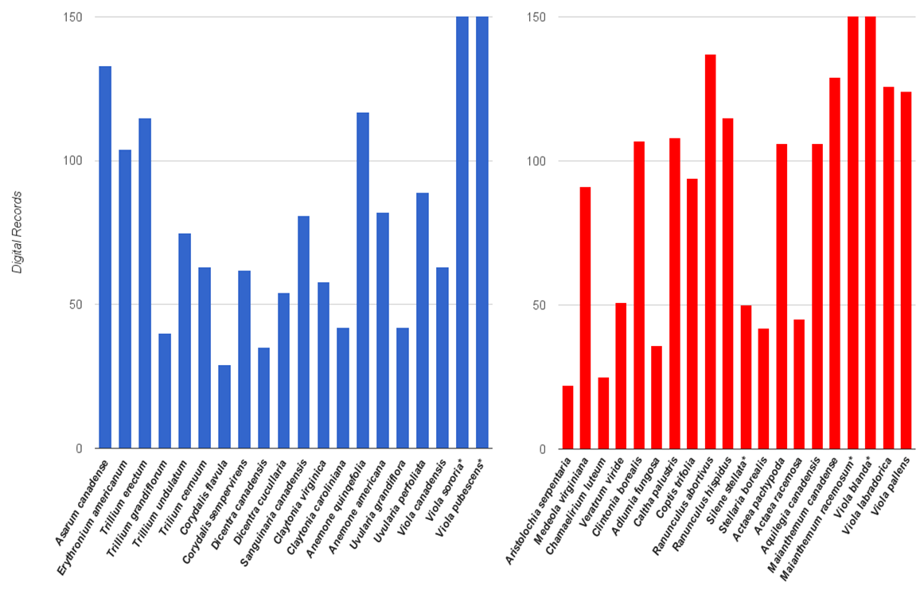

Digital records for 20 species of ant-dispersed from Connecticut forests deposited in the UConn herbarium (1729 records in blue), to be compared with vertebrate-dispersed species and found in the same habitats (1861 records in red). All ant-dispersed plants are reportedly dispersed by *Aphaenogaster* ants, while vertebrate-dispersed plants in this list produce seeds or berries that are consumed by migratory or resident birds and mammals. Plant phylogenetic groups determined using current Angiosperm phylogeny (Stephens, P. F. 2001, Angiosperm Phylogeny Group 2016) and preliminary data from Uconn herbarium. All listed species have >20 records, while asterisk indicate species with >150 records.

**Experimental Design**

The proposed project integrates herbarium records, forest fragmentation/GIS data, fieldwork, and statistical modeling to address each hypothesis.

To test the **population persistence hypothesis**, herbaria records will be analyzed to determine a list of population localities for each species, and these localities will be cross-referenced with the CLEAR database to determine the fragment size the plant was collected in. This analysis will then use the locality information to generate a list of 120 individual field assessments (5 sites per plant species) to verify presence or absence of plant populations across a gradient of fragments. This analysis will compare 20 ant-dispersed plant species to 20 vertebrate-dispersed species to determine if ant-dispersed species are less likely to be observed in small fragments, using plant species as a random effect in all models. To find plants, we will search within 50x50m plot surveys with the GPS waypoint centered on the collection record locality.

Both analysis of herbaria records and assessment of population persistence in varying fragment sizes will determine if there is a negative relationship between forest fragmentation and the presence of ant-dispersed vs. vertebrate-dispersed plants. This will determine if population persistence is indeed predicted by forest fragment size and seed dispersal mode. While theory predicts that populations will be lower in small fragments for both groups, PPH would be supported if population persistence is less likely for ant-dispersed plants compared to vertebrate-dispersed plants.

To test the **spatial structure hypothesis**, the spatial structure of plant populations will be recorded in spring and summer of 2018 and 2019. Representative species will be used to analyze how spatial structure has changed in different forest fragments. Six species chosen will be those with >100 records since these indicate widespread plants found abundantly in disturbed and undisturbed habitats. For example, *Erythronium americanum* (ant-dispersed plant) and *Mianthemum canadense* (vertebrate-dispersed plant) are abundant according to herbarium records (Fig. 2), and botanical maps (Gleason and Cronquist, 1991). In each habitat we will designate 25x25-m2 plots in which the spatial location of individual plants in will be recorded (following Bagchi et al. 2011). We will sample the ant community using 25 pitfall traps at 5-m intervals in these plots. Ants will be collected from these traps to measure ant community composition and average body size of the ant community.

SSH would be supported if ant-dispersed plants were more clustered as fragment size decreases, while fragmentation has no effect or a weaker effect on the clustering of vertebrate-dispersed plants. Furthermore, ant-mediated mechanisms underlying SSH would also be supported if 1) clustering of ant-dispersed plants happened in locations where *Aphaenogaster* mutualists were rare or absent in the ant community, and 2) plants were more clustered in locations with smaller average ant body size for the whole ant community. We will regress plant spatial structure against dispersal syndrome, fragment size and their interaction using replicated point pattern analysis (Bagchi and Illian, 2015). We will also repeat the regression using the principle axes from ordinations of the ant community to determine the impacts of ant community composition on the spatial structure of myrmecochorous plant populations.

To test the **dispersal co-evolution hypothesis**, analyses and experiments will examine herbaria records for understory flowering plants containing seed specimens. In these records, plants were collected in summer when these plants were producing seeds, providing data on seeds per plant and the size of seeds measured by dry seed weight. Ant-dispersed and vertebrate-dispersed seed sizes will be compared between field-collected samples from PPH and historical data. As a result, there will be a range of seed traits collected across a continuum of forest fragment sizes for multiple plant species. In an undergraduate collaborative project, a behavioral assay in the field will determine ant response to different seed sizes using seeds collected in the field from highly abundant populations indentified in collections. In forest fragments near Uconn, experiments will compare seed dispersal behavior of *Aphaenogaster* (forest interior ants), *Lasius,* and *Tetramorium* (forest edge ants)*.*

The DCH will be supported if we observe that ant-dispersed plants' seed sizes are smaller on average in locations that have been fragmented compared to seeds of vertebrate-dispersed plants. Additionally, declines in myrmecochore seed size in forest fragments that have become smaller over the last three decades would indicate rapid evolutionary change in seed size as a consequence of forest fragmentation. Additionally, evidence for natural selection on seed traits by ants would further support the DCH iflarge seeds are less likely to be transported by species *Lasius* and *Tetramorium,* compard to *Aphaenogaster*. Furthermore, indirect evidence for selection of small seeds by ants would be provided if species that tend to remain in small fragments exhibited smaller seed size traits compared to other members of this guild.

**Training objectives, career advancement, and choice of institution**

Areas of expertise between PI Clark and Sponsor Bagchi complement each other for a project on ant-mediated seed dispersal and the effects of forest fragmentation on understory plant populations. The PI’s graduate research experience has focused primarily on ant community ecology and plant-arthropod interactions. The project objectives fit the research program of sponsor Bagchi, which includes examining the effect of anthropogenic environmental change on plant diversity and seed dispersal ecology. Experiments provide opportunities to train undergraduate students, aligning with the PI’s goal of finding a position at a primarily undergraduate institution focused on teaching and research in ecology and conservation. Additionally, this project synergizes with other research with Bagchi and collaborators examining the effects of forest fragmentation in Connecticut forests on dietary specialization of herbivorous caterpillars through altered resource availability and predation (NSF DEB –1557086), allowing mutual logistical support, shared data on forest fragmentation and GIS, and shared travel cost when available.

Due to wide range of field sites proposed for experiments in Connecticut forests, this project provides significant opportunities for training in GIS. Cross-referencing herbarium records with location data, forest fragment size, and then finding these locations is a significant challenge that will require detailed knowledge of land use history. Training will be provided UConn’s Center for Land Use Education and Research programs, which offers a Geospatial Training Program (GTP) in GIS and interpretation of land-use records for biologists. This project will also gather a large amount of spatially and phylogenetically correlated data on plant populations. To meet the challenge, the PI will be trained in use of R forgeneralized least squares and hierarchal Bayesian modeling from the sponsor, and participate in courses in ecological modeling offered by PR statistics, including SPAE (Spatial Analysis of Ecological Data in R), ABME (Applied Bayesian Modeling for Ecologists), and PHYG (Introduction to Phylogenetic Data Analysis in R).

**Broader Impacts**

Habitat fragmentation is key challenge in conservation biology (Wilson et al. 2016). It is estimated that 11,000 species of plants globally depend on seed dispersal by ants (Lengyel et al. 2010) and loss of dispersal services due to anthropogenic disturbance is a critical conservation question in the conservation of these flowering plants. For example, *Fremontodendron decumbens*, a critically endangered species has experienced population decline due to reduced seed dispersal by ants and resultant increased mortality from seed predators (Boyd 2001). Conversely, many myrmecochorous plants are highly abundant and some species dominate forest understories (Ness et al. 2009). Species like *Erythronium americanum* can dominate forest understories, making significant contributions to soil nitrogen cycles through nutrient uptake (Tessier and Raynal 2003), but it is unclear how habitat fragmentation may impact their populations since some reports show decline of *E. americanum* in highly disturbed environments (Ness and Morin, 2008). Ants may help these plants remain resilient in the face of environmental change, for example, *Viola* species may gain protection from soil disturbance and changes in water regimes as long as their mutualism services are maintained (Prinzing et al. 2008).

The citizen science components of the program used to test PPH will provide outreach programs for the public, improving public understanding of wildflower conservation in the region. These programs follow similar format to 18 “citizen science” outdoor programs I offered during my graduate work. Additionally, Sponsor Bagchi is a current mentor for the McNair program at UConn. McNair scholars will participate in experiments examining DCH, which requires measuring plant seed size traits and evaluating how seed size determines dispersal success by ants in fragmented habitats. Both lab and field components will provide undergraduate students training in plant taxonomy, insect behavior, data analysis, and fieldwork logistics.

Rapid evolution of plant traits in response to loss or change in dispersal mutualism is predicted from emerging research in evolutionary ecology (Carroll et al. 2007, Urban 2011, Urban et al. 2012). Biological collections are a central part of this research program since they provide historical data on species traits (Leger 2013). Additionally, the proposed study will address changes in seed traits following forest fragmentation that may be response to altered natural selection on seed dispersal biology, but also evidence of host switching if we observe that smaller ants are capable of effectively dispersing seeds as long as the seeds are small enough. This will have significant contributions to conservation of wildflowers and plants, suggesting that rapid adaptation may help mitigate some of the impacts of habitat disturbance

In the process of these experiments, specimen records will be organized and further data will be generated from already collected specimens, particularly seed traits. This will contribute to the UConn herbaria database which is online and available to the public. Use of digitized of herbarium collections and aggregating data with relation to GIS can be by future ecologists and conservation biologists. Data collected on seed traits will be made publically avaible to anyone who used the Uconn herbaria, and data collected on plant population persistence and spatial structure will be shared on Dryad Digital Repository.

**Training and Research Timeline (make a neater timeline like caterpillar forest fragmentation grant)**

The proposed timeline for this project is two years, from September 1 2017 to August 31 2019. **Fall 2017 –** generation of primary data set of herbarium records to test PPH and training in Ecological Modeling for Phylogenetically Correlated data. **Winter 2017 –** Training in GIS and cross-referencing of site records from herbaria with forest fragmentation data to be used in testing PPH and SSH. **Spring 2018 –** Part 1 of fieldwork testing PPH and SSH. **Summer 2018 –** Fieldwork testing DCH with behavioral seed trait experiments and sorting of ants collected to test. **Fall 2018 –** Training in Applied Bayesian Modeling and Spatial Analysis of Ecological Data. **Winter 2018 –** Analysis of field and herbaria data testing PPH, SSH and DCH. **Spring 2019 –** Additional data testing PPH, SSH, and DCH, filling in any gaps in coverage. **Summer 2019 –** Integration of new data and submission of manuscripts for publication.

**References**

Aguilar, R., L. Ashworth, L. Galetto, and M. A. Aizen. 2006. Plant reproductive susceptibility to habitat fragmentation: review and synthesis through a meta-analysis. Ecology Letters 9:968–980.

Bagchi, R., P. A. Henrys, P. E. Brown, D. F. R. P. Burslem, P. J. Diggle, C. V. S. Gunatilleke, I. A. U. N. Gunatilleke, A. R. Kassim, R. Law, S. Noor, and R. L. Valencia. 2011. Spatial patterns reveal negative density dependence and habitat associations in tropical trees. Ecology 92:1723–1729.

Bagchi, R., and J. B. Illian. 2015. A method for analysing replicated point patterns in ecology. Methods in Ecology and Evolution 6:482–490.

Bas, J. M., J. Oliveras, and C. Gomez. 2009. Myrmecochory and short-term seed fate in Rhamnus alaternus: Ant species and seed characteristics. Acta Oecologica-International Journal of Ecology 35:380–384.

Boyd, R. S. 2001. Ecological benefits of myrmecochory for the endangered chaparral shrub Fremontodendron decumbens (Sterculiaceae). American Journal of Botany 88:234–241.

Bronstein, J. L., R. Alarcón, and M. Geber. 2006. The evolution of plant–insect mutualisms. New Phytologist 172:412–428.

Canner, J. E., R. R. Dunn, I. Giladi, and K. Gross. 2012. Redispersal of seeds by a keystone ant augments the spread of common wildflowers. Acta Oecologica 40:31–39.

Carroll, S. P., A. P. Hendry, D. N. Reznick, and C. W. Fox. 2007. Evolution on ecological time-scales. Functional Ecology 21:387–393.

Center for Land use Education And Research (2012) 2010 Land Cover Data. Center for Land use Education and Research (CLEAR), Connecticut, USA. doi: http://clear.uconn.edu/projects/landscapelis/pdfs/LandCover2010_v2-03_metadata.pdf

Clark, R. E., and J. R. King. 2012. The ant, Aphaenogaster picea, benefits from plant elaiosomes when insect prey is scarce. Environmental Entomology 41:1405–1408.

Cordeiro, N. J., and H. F. Howe. 2003. Forest fragmentation severs mutualism between seed dispersers and an endemic African tree. Proceedings of the National Academy of Sciences of the United States of America 100:14052–14056.

Ellison, A. M., S. Record, A. Arguello, and N. J. Gotelli. 2007. Rapid Inventory of the Ant Assemblage in a Temperate Hardwood Forest: Species Composition and Assessment of Sampling Methods. Environmental Entomology 36:766–775.

Ewers, R. M., and R. K. Didham. 2006. Confounding factors in the detection of species responses to habitat fragmentation. Biological Reviews 81:117–142.

Fahrig, L. 2003. Effects of habitat fragmentation on biodiversity. Annual Review of Ecology Evolution and Systematics 34:487–515.

Fedriani, J. M., P. J. Rey, J. L. Garrido, J. Guitián, C. M. Herrera, M. Medrano, A. M. Sánchez-Lafuente, and X. Cerdá. 2004. Geographical variation in the potential of mice to constrain an ant-seed dispersal mutualism. Oikos 105:181–191.

Fischer, J., and D. B. Lindenmayer. 2007. Landscape modification and habitat fragmentation: a synthesis. Global Ecology and Biogeography 16:265–280.

Foster, D. 1992. Land-Use History (1730-1990) and Vegetation Dynamics in Central New-England, Usa. Journal of Ecology 80:753–772.

Garrido, J. L., P. J. Rey, X. Cerdá, and C. M. Herrera. 2002. Geographical Variation in Diaspore Traits of an Ant-Dispersed Plant (Helleborus foetidus): Are Ant Community Composition and Diaspore Traits Correlated? Journal of Ecology 90:446–455.

Garrido, J. L., P. J. Rey, and C. M. Herrera. 2009. Influence of elaiosome on postdispersal dynamics of an ant-dispersed plant. Acta Oecologica 35:393–399.

Gomez, C., P. Pons, and J. M. Bas. 2003. Effects of the Argentine ant Linepithema humile on seed dispersal and seedling emergence of Rhamnus alaternus. Ecography 26:532–538.

Gómez, C., and X. Espadaler. 2013. An update of the world survey of myrmecochorous dispersal distances. Ecography 36:1193–1201.

Guitián, J., and J. L. Garrido. 2006. Is early flowering in myrmecochorous plants an adaptation for ant dispersal? Plant Species Biology 21:165–171.

Harrison, R. D., S. Tan, J. B. Plotkin, F. Slik, M. Detto, T. Brenes, A. Itoh, and S. J. Davies. 2013. Consequences of defaunation for a tropical tree community. Ecology Letters 16:687–694.

Kwit, C., G. J. Marcello, J. L. Gonzalez, A. C. Shapiro, and R. D. Bracken. 2012. Advantages of Seed Dispersal for a Myrmecochorous Temperate Forest Herb. American Midland Naturalist 168:9–17.

Lach, L., C. L. Parr, and K. L. Abbott. 2010. Ant ecology. Oxford University Press, Oxford.

Laurance, W. F., H. E. M. Nascimento, S. G. Laurance, A. Andrade, J. E. L. S. Ribeiro, J. P. Giraldo, T. E. Lovejoy, R. Condit, J. Chave, K. E. Harms, and S. D’Angelo. 2006. Rapid decay of tree-community composition in Amazonian forest fragments. Proceedings of the National Academy of Sciences of the United States of America 103:19010–19014.

Leger, E. A. 2013. Annual plants change in size over a century of observations. Global Change Biology 19:2229–2239.

Lengyel, S., A. D. Gove, A. M. Latimer, J. D. Majer, and R. R. Dunn. 2010. Convergent evolution of seed dispersal by ants, and phylogeny and biogeography in flowering plants: A global survey. Perspectives in Plant Ecology, Evolution and Systematics 12:43–55.

Liu, Z., C. He, and J. Wu. 2016. The Relationship between Habitat Loss and Fragmentation during Urbanization: An Empirical Evaluation from 16 World Cities. Plos One 11:e0154613.

Morales, M. A., and E. R. Heithaus. 1998. Food from Seed-Dispersal Mutualism Shifts Sex Ratios in Colonies of the Ant Aphaenogaster rudis. Ecology 79:734–739.

Ness, J. H., J. L. Bronstein, A. N. Andersen, and J. N. Holland. 2004. Ant Body Size Predicts Dispersal Distance of Ant-Adapted Seeds: Implications of Small-Ant Invasions. Ecology 85:1244–1250.

Ness, J. H., and D. F. Morin. 2008. Forest edges and landscape history shape interactions between plants, seed-dispersing ants and seed predators. Biological Conservation 141:838–847.

Ness, J. H., D. F. Morin, and I. Giladi. 2009. Uncommon specialization in a mutualism between a temperate herbaceous plant guild and an ant: are Aphaenogaster ants keystone mutualists? Oikos 118:1793–1804.

Peters, M., R. Oberrath, and K. Bohning-Gaese. 2003. Seed dispersal by ants: are seed preferences influenced by foraging strategies or historical constraints? Flora 198:413–420.

Prinzing, A., J. Dauber, E. Hammer, N. Hammouti, and K. Böhning-Gaese. 2008. Does an ant-dispersed plant, Viola reichenbachiana, suffer from reduced seed dispersal under inundation disturbances? Basic and Applied Ecology 9:108–116.

Radeloff, V. C., R. B. Hammer, S. I. Stewart, J. S. Fried, S. S. Holcomb, and J. F. McKeefry. 2005. The wildland-urban interface in the United States. Ecological Applications 15:799–805.

Rocha-Santos, L., M. S. Pessoa, C. R. Cassano, D. C. Talora, R. L. L. Orihuela, E. Mariano-Neto, J. C. Morante-Filho, D. Faria, and E. Cazetta. 2016. The shrinkage of a forest: Landscape-scale deforestation leading to overall changes in local forest structure. Biological Conservation 196:1–9.

Rico-Gray, V., and P. S. Oliveira. 2007. The ecology and evolution of ant-plant interactions. University of Chicago Press, Chicago.

Stevens, P.F. 2001. Angiosperm Phylogeny Website. Version 12, July 2012 [and more or less continuously updated since]." will do. <http://www.mobot.org/MOBOT/research/APweb/>

Tessier, J.T. and D.J. Raynal. 2003. Vernal nitrogen and phosphorus retention by forest understory vegetation and soil microbes. Plant and Soil 256:443-453.

The Angiosperm Phylogeny Group. 2016. An update of the Angiosperm Phylogeny Group classification for the orders and families of flowering plants: APG IV Bot. J. Linn. Soc. 181: 1-20. doi: mobot.org/MOBOT/research/APweb/

Thompson, J. N. 1981. Elaiosomes and Fleshy Fruits: Phenology and Selection Pressures for Ant-Dispersed Seeds. The American Naturalist 117:104–108.

Urban, M. C. 2011. The evolution of species interactions across natural landscapes. Ecology Letters 14:723–732.

Urban, M. C., L. De Meester, M. Vellend, R. Stoks, and J. Vanoverbeke. 2012. A crucial step toward realism: responses to climate change from an evolving metacommunity perspective. Evolutionary Applications 5:154–167.

Warren, R. J., and I. Giladi. 2014. Ant-mediated seed dispersal: A few ant species (Hymenoptera: Formicidae) benefit many plants. Myrmecological News 20:129–140.

Warren, R. J., I. Giladi, and M. A. Bradford. 2010. Ant-mediated seed dispersal does not facilitate niche expansion. Journal of Ecology 98:1178–1185.

Wilson, M. C., X.-Y. Chen, R. T. Corlett, R. K. Didham, P. Ding, R. D. Holt, M. Holyoak, G. Hu, A. C. Hughes, L. Jiang, W. F. Laurance, J. Liu, S. L. Pimm, S. K. Robinson, S. E. Russo, X. Si, D. S. Wilcove, J. Wu, and M. Yu. 2016. Habitat fragmentation and biodiversity conservation: key findings and future challenges. Landscape Ecology 31:219–227.

Yates, E. D., D. F. Levia, and C. L. Williams. 2004. Recruitment of three non-native invasive plants into a fragmented forest in southern Illinois. Forest Ecology and Management 190:119–130.